Determining the Index of Refraction Lab

Purpose: To determine the index of refraction of different materials by ray tracing of refracted light rays.

Apparatus: Various shapes (rectangle, triangle and half-circle) comprised of various materials, laser, ruler, pencil, protractor, drawing paper, sheet of cardboard.

Required time: Two periods

Introduction: The index of refraction is defined as the ratio, of the speed of light in a vacuum, to the speed of light in a medium. Since the speed of light in air is only slightly different from the speed of light in a vacuum, a negligible error is introduced when we measure the index of refraction by permitting light to travel from air into another medium. However, the speed of light in other media is significantly different. A consequence of this change in speed is that the path that light follows changes as it transitions from one medium to another. Willebrord Snell provided a simple direct method of measuring the index of refraction by defining it in terms of functions of the angle of incidence and the angle of refraction. The mathematical relationship, known as Snell’s law, is:

n₁ sin θ₁ = n₂sin θ₂

where n₁ and n₂ are the indices of refraction of the two materials on either side of the interface, θ₁ is the angle of incidence, and θ₂ is the angle of refraction. In Figure 1, n₁ will closely approximate 1 since it is air, and the relationship can be simplified to:

sin θ₁
n₂ =
sin θ₂

The index of refraction of any material varies with its composition and with the wavelengths of light incident upon it. Ordinary crown glass, when illuminated by white light, has a refractive index of 1.52; medium flint glass has an index of 1.63. Your experimental results should be precise enough to enable you to identify the kind of materials used in this experiment. Because the table attached is based upon a yellow wavelength of light, your results may differ from the actual values by a few hundredths.

Normal

AIR

GLASS

θ₁

θ₂

Figure 1:
Procedure:
- Place the rectangular glass on the center of a sheet of paper and outline it with a sharp pencil.
- Mark a point at ~1-4 centimeters from one of the corners on the long edge as B in Figure 2 below.
- Draw a line such that it creates an angle of incidence with the block that is greater than 0°.
- Place an additional point at A, not less than 7 cm from B.
- Use the laser and shine it along this line at your block.
- Mark two points at least 5 cm apart where the beam leaves the block, and label them C and D.
- Remove the glass plate, and join the points, A, B, C and D to represent the path of the light traveling from A through the air to B, through the glass to C and back to air to D. Identify the incident ray AB and the refracted ray BC. Do not forget to include your arrowheads.
- From B construct the normals, NB and BN’ to the edge of the glass block along EF, and NC and CN' along the opposite edge of the block.
- By means of a protractor, measure the angles of incidence, θ_{i1} and θ_{i2}, and the angles of refraction, θ_{r1} and θ_{r2}. Record this data, then use it to compute the index of refraction using the ratio of the sines as described in the introduction.
- Repeat this process in similar fashion for the triangular piece of material (See Figure 3). The path should appear similar to the path light followed in dispersion. See Pink Floyd Dark Side of the Moon album.
- Fill the half circle container with water about half way. Then repeat the process twice more for the half circle. Place a point (B) at the “center” of the flat side of the half-circle. Then mark points A, B, and C, in two sets of locations such that two rays will enter at angles greater than 0º less than 90º. Use Figure 4 as your guide.
- Finally, find the critical angle using Figure 5 as your guide.
- On each drawing, show your work for determining the index of refraction for the unknown material.

D
F
N
N’
Θ_{i}
1 – 4 cm
Glass Block
N
N’
Θ_{r1}
A

Θ_{i1}
B
E

Θ_{r2}
C

Figure 2:

Data:
Trial | Θ_{i1}(°) | Θ_{r1}(°) | Index of Refraction* | Θ_{i2}(°) | Θ_{r2}(°) | Index of Refraction* | Avg. n
Rectangle
Triangle
Half-Circle (1)
Half-Circle (2)
Half-Circle (critical angle)
Average
*Remember, you must use Snell's Law to determine the Index of Refraction: n₁sinθ₁ = n₂sinθ₂.

Analysis:
- What is the size of the angle of refraction if the angle of incidence is 0°?
- What is meant by the critical angle?
- Compare rays AB and DC for the rectangular block (see figure 2). What can you say about their relationship to one another?
- Using your experimental results, try to identify the type of material that makes up each shape that you used in this experiment by comparing your average values for n to those in the table below. Explain any discrepancies that you feel may exist.
- Determine the speed of light in each of the shapes, using your average value for the index of refraction and the relationship v = c/n. Show all your work!
- Why is only the flat side of the half circle used in finding the index of refraction?
- What are your major sources of error? How strongly do you think they affect your results?

Conclusions:

Absolute Indices of Refraction
(f = 5.09 x 10¹⁴ Hz)
Air | 1.00
Diamond | 2.42
Ethyl Alcohol | 1.36
Glass, Crown | 1.52
Glass, Flint | 1.66
Glycerol | 1.47
Lucite | 1.50
Plastic | 1.46
Plexiglas | 1.50
Polystyrene | 1.55
Quartz, Fused | 1.46
Quartz, Crystalline | 1.54
Sodium Chloride | 1.54
Water | 1.33
Zircon | 1.92

Figure 3:
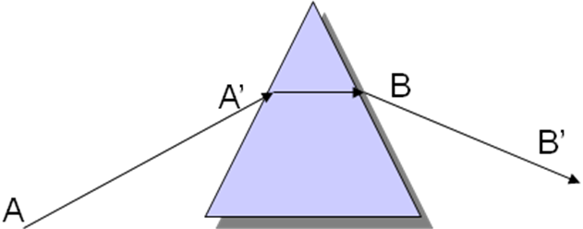
B
C
D

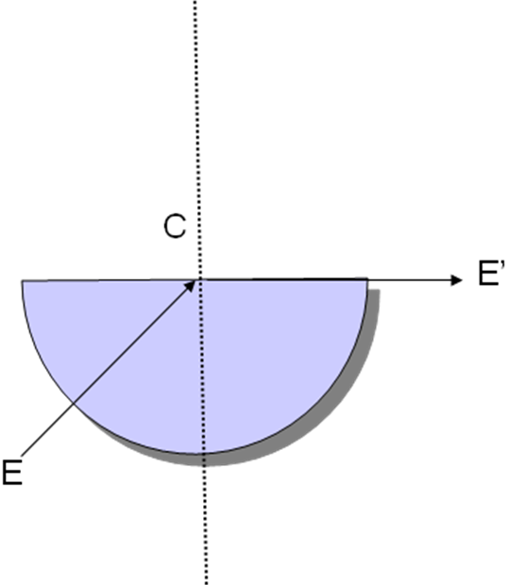
Figure 5:

B
C

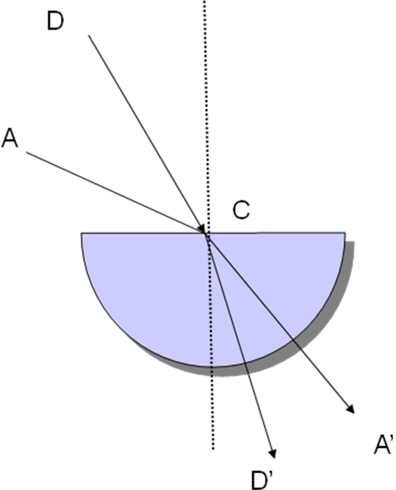
Figure 4:
A'

B

C
C'

A

